1. **Facility Name:**

Chandler, Good Samaritan and Kentucky Children’s Hospital

1. **Contact Name, Phone, and Email**

Contact Name

Justin T. Perry, MHA, CPC  
Assistant Director - Coding & Reimbursement

UKHC Revenue Management

1648 McGrathiana Pkwy, Suite 340

Lexington, KY 40511-1339

Office: 859-218-2002 | Cell: 859-213-0071

jperr2@uky.edu

Informaticist

Pamela J Roundtree

Catherine S (Cathy) Roe

Technical

Stephen (Steve) Crawford

IT Technical

Sharon MacLaughlin

Project Manager

1. **Report Name:**

SCM_Attending_And_Resident_Notes_Signed_Yesterday_V2

1. **Report Type:**

Schedule to extract daily from SSRS an Excel file of documents signed yesterday in SCM

1. **Report Description:**

*Please provide a brief description of the purpose and content of the report.*

|  |
| --- |
| Purpose is to identify documents in SCM for coding until the 3M module for computer assisted coding is implemented. The documents in SCM have been signed, authored or modified yesterday by a billable provider. |

1. **Report Details:**

* *Enlarged sections below are in one row in the data extract.*

|  |
| --- |
|  |

* Document GUID: unique identifier for a document, not visible in SCM, is a 16 digit number which has the exponential display format in Excel. Example 9.02831E+15 for 9028309376702040.
* HQ Visit Number: SCM Visit ID, aka Encounter or Account, Visit in the document header on the upper right, 2nd row

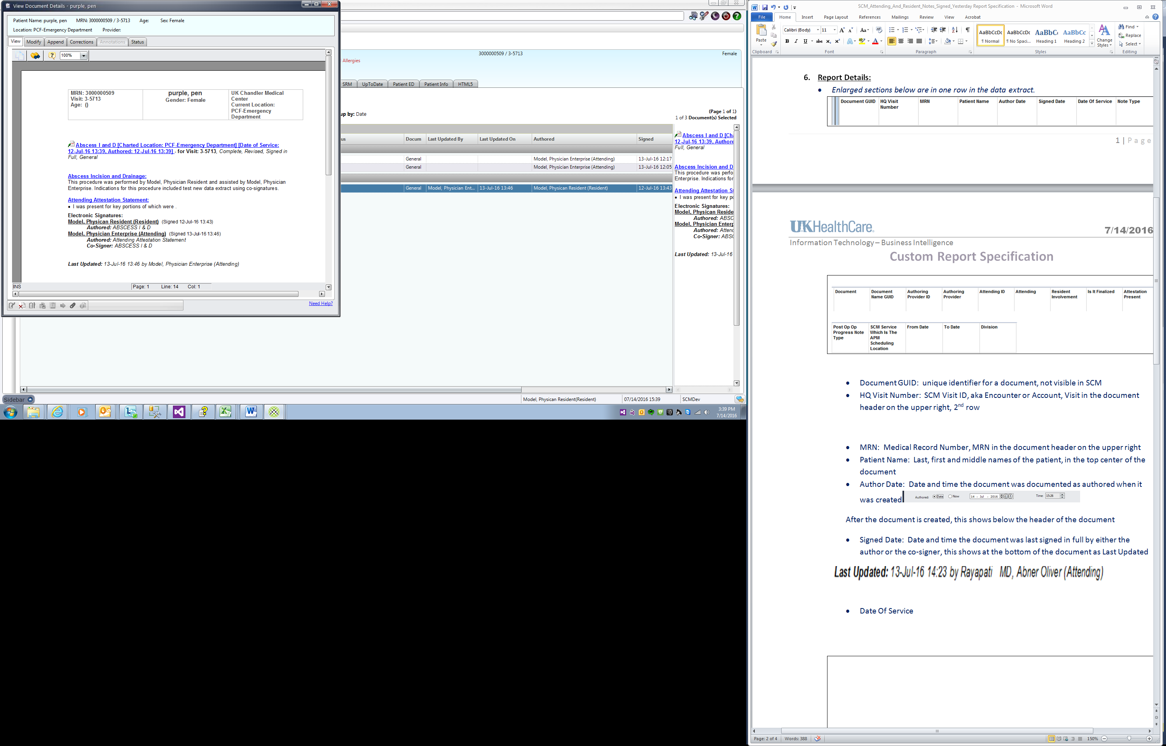

* MRN: Medical Record Number, MRN in the document header on the upper right
* Patient Name: Last, first and middle names of the patient, in the top center of the document
* Author Date: Date and time the document was documented as authored when it was created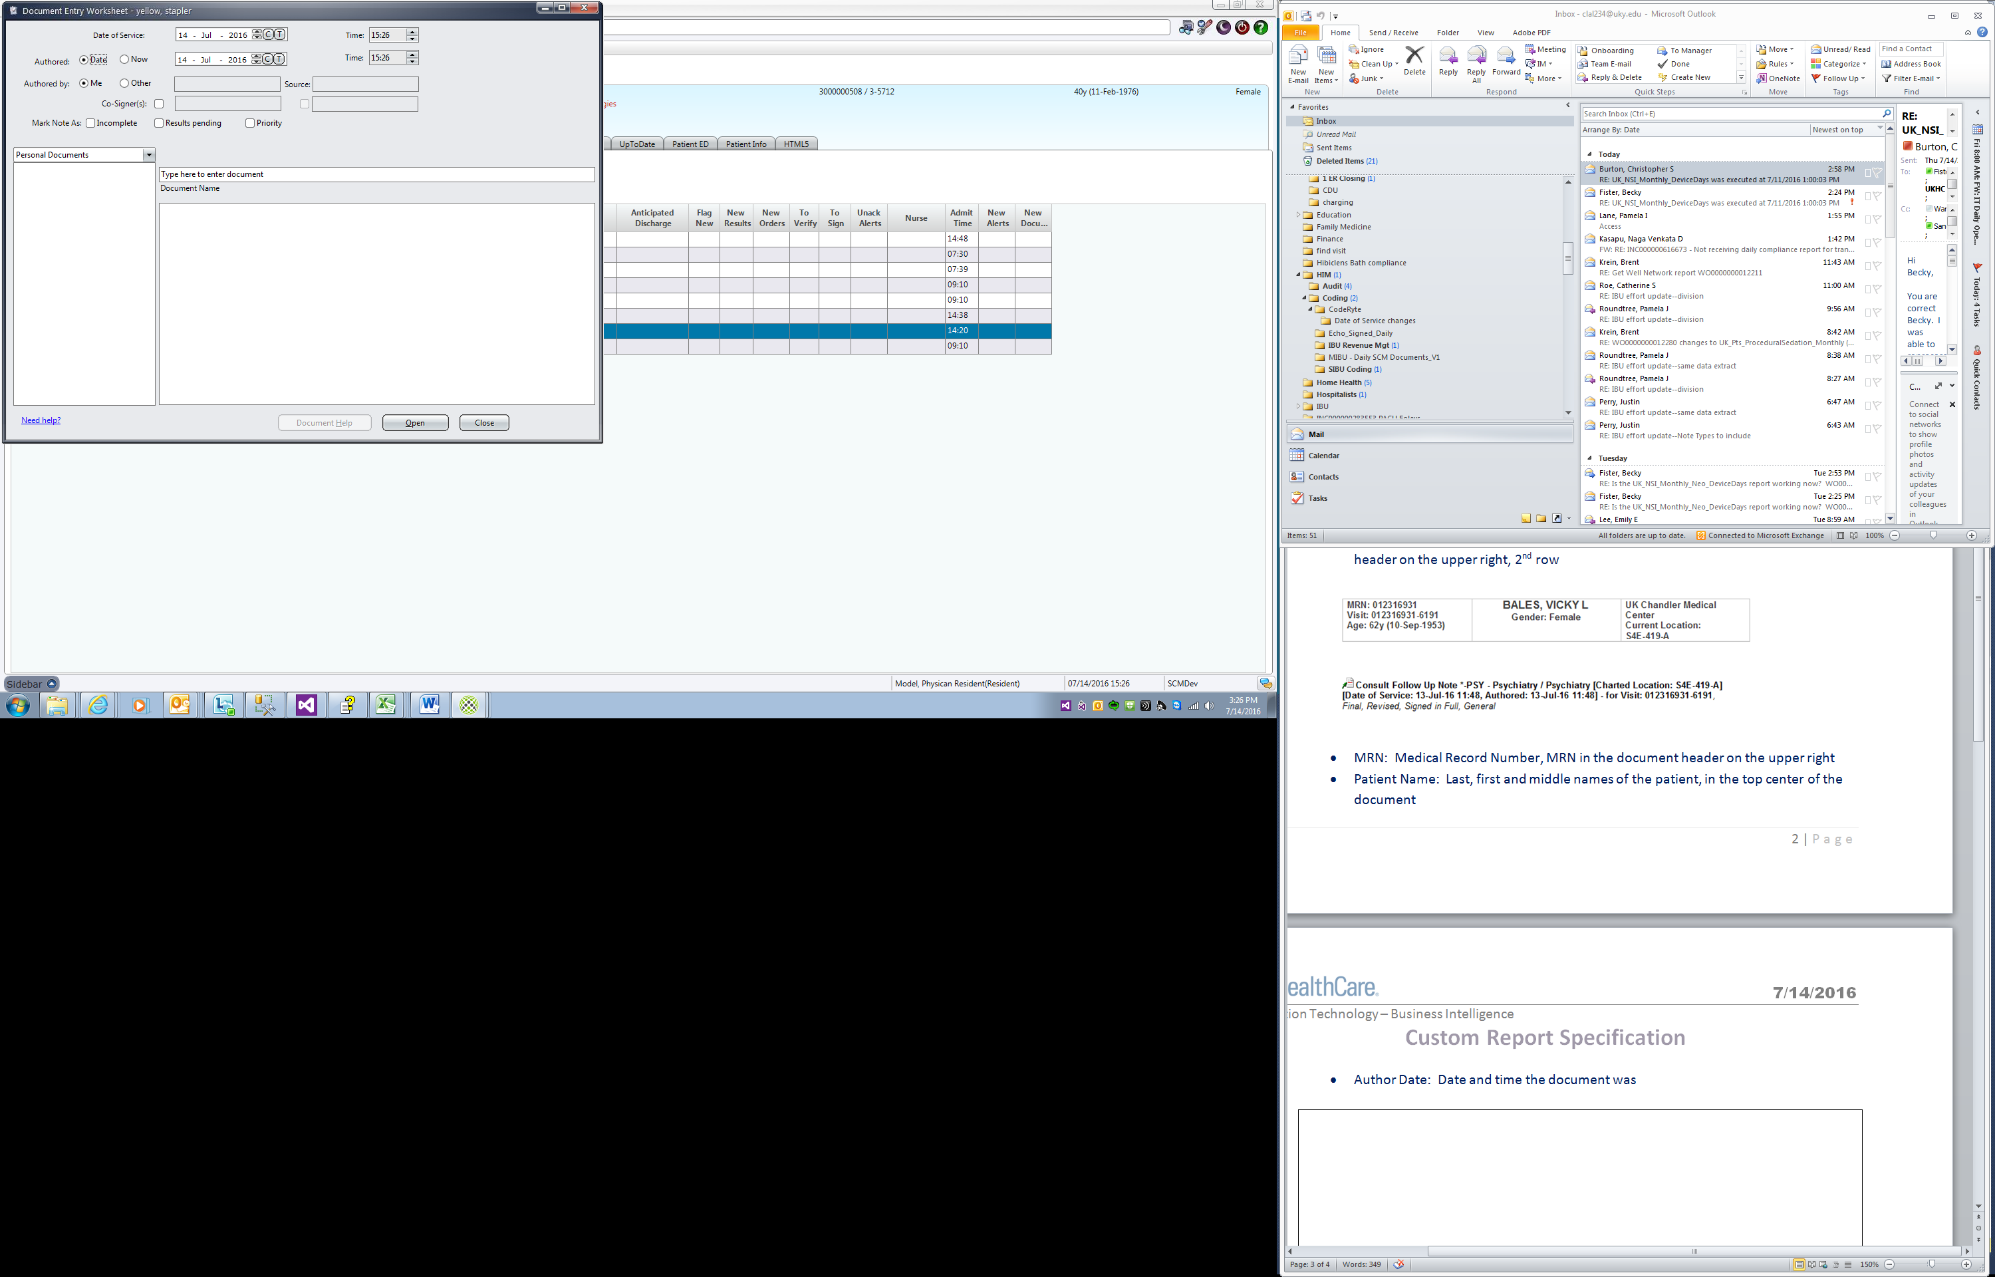

After the document is created, this shows below the header of the document

* Signed Date: Date and time the document was last signed in full by either the author or the co-signer, this shows at the bottom of the document as Last Updated



* Date Of Service: Date and time below the header of the document



* Note Type: document review subcategory if one exists, if not, then the document review category, if one exists, if not, then the document name

In the example below, “Progress Notes” is the document review subcategory, “Inpt. Provider Notes” is the document review category and “Progress Note-ALL – Medicine / Allergy” is the document name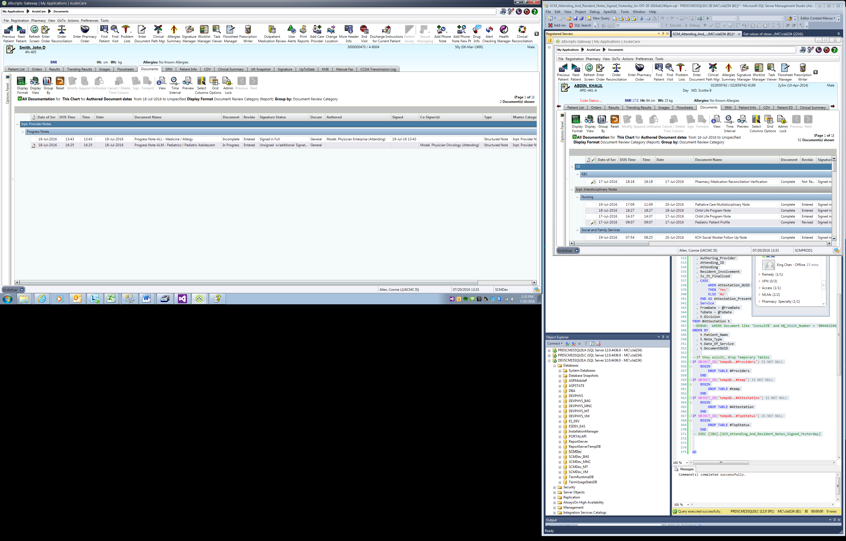

* Document: Name at the top of the document below the header and in the Document Name column inside SCM. In the screen print above “Progress Note-ALL – Medicine / Allergy” is the document. In the screen print below, Abscess I and D” is the document.



* Document Name GUID: Unique identifier for this document name
* Authoring Provider ID: For the person who created the document, the ID of the ID Type “Primary ID” in SCM which is the HQPM number of the person
* Authoring Provider: Name of the person who created the document. In SCM on the Documents tab, this is the Authored column. On the document, this is the first name at the bottom under Electronic Signatures. In the screen print below, this is “Model, Physican Resident”



* Document Signer ID: The ID of the ID Type “Primary ID” in SCM which is often the HQPM number of the billable provider who last changed the document in SCM, unless it was last changed by the interfaces. If it was last changed by the interfaces, it is the Primary ID of the last Authored By who is a billable provider. If no billable provider has changed it and no billable provider has signed it and it crossed the interfaces, then the Primary ID of the author will be in this field.
* Document Signer: The billable provider who last changed the document in SCM, unless it was last changed by the interfaces. If it was last changed by the interfaces, it is the last Authored By who is a billable provider. If no billable provider has changed it and no billable provider has signed it and it crossed the interfaces, then the author will be in this field.
* Resident Involvement: If the person who authored the document is of occupation “Resident”, then Yes, otherwise No
* Is It Finalized: Document Status column in the screen print below.

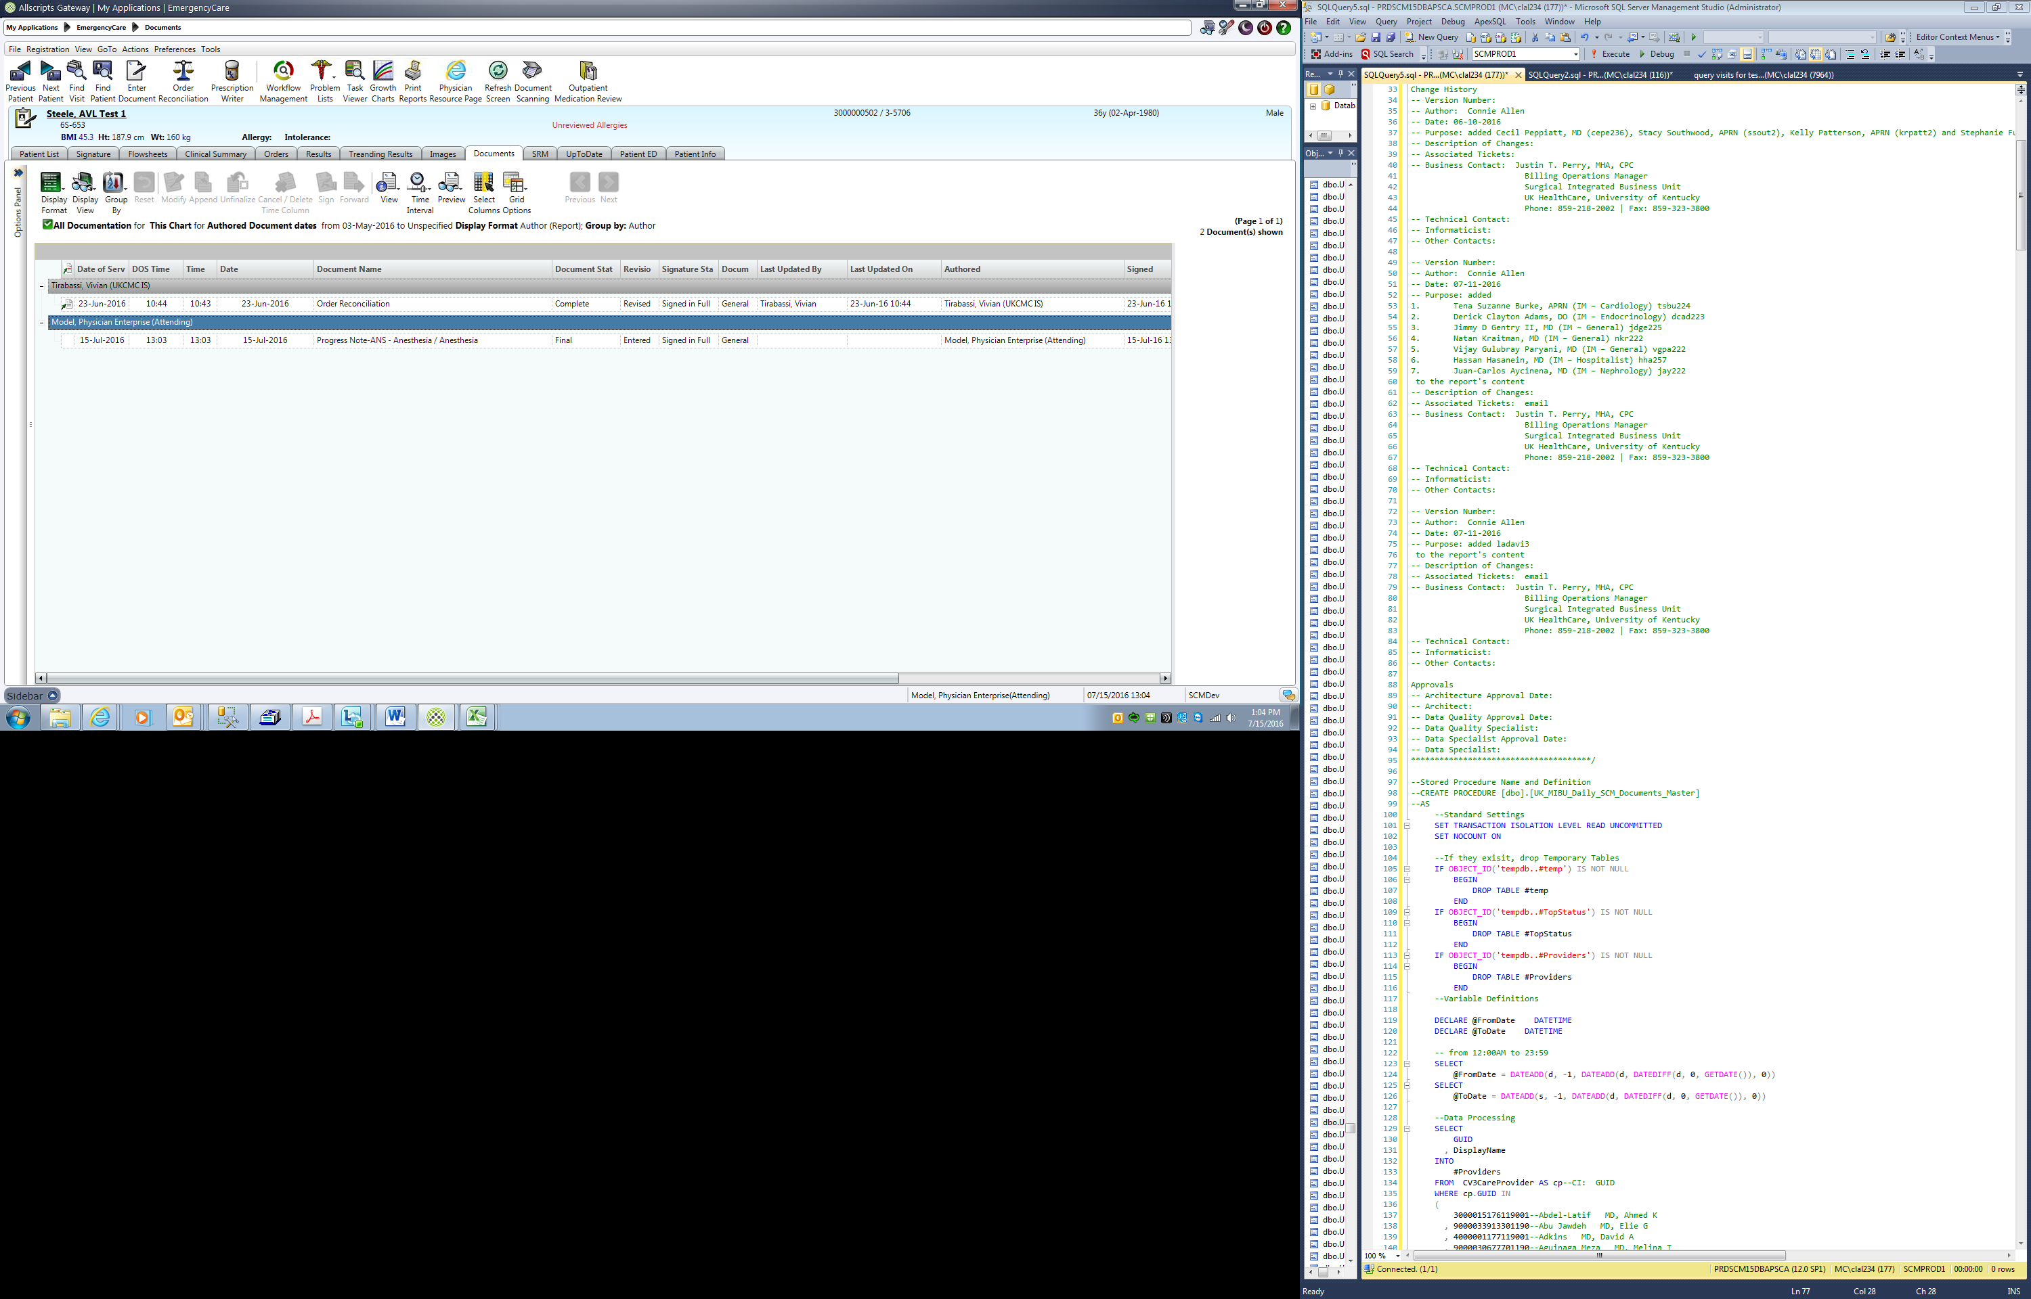

* Attestation Present: If the bottom of the document includes one or more selections in the Attending Attestation section as shown below, then Yes, otherwise No.

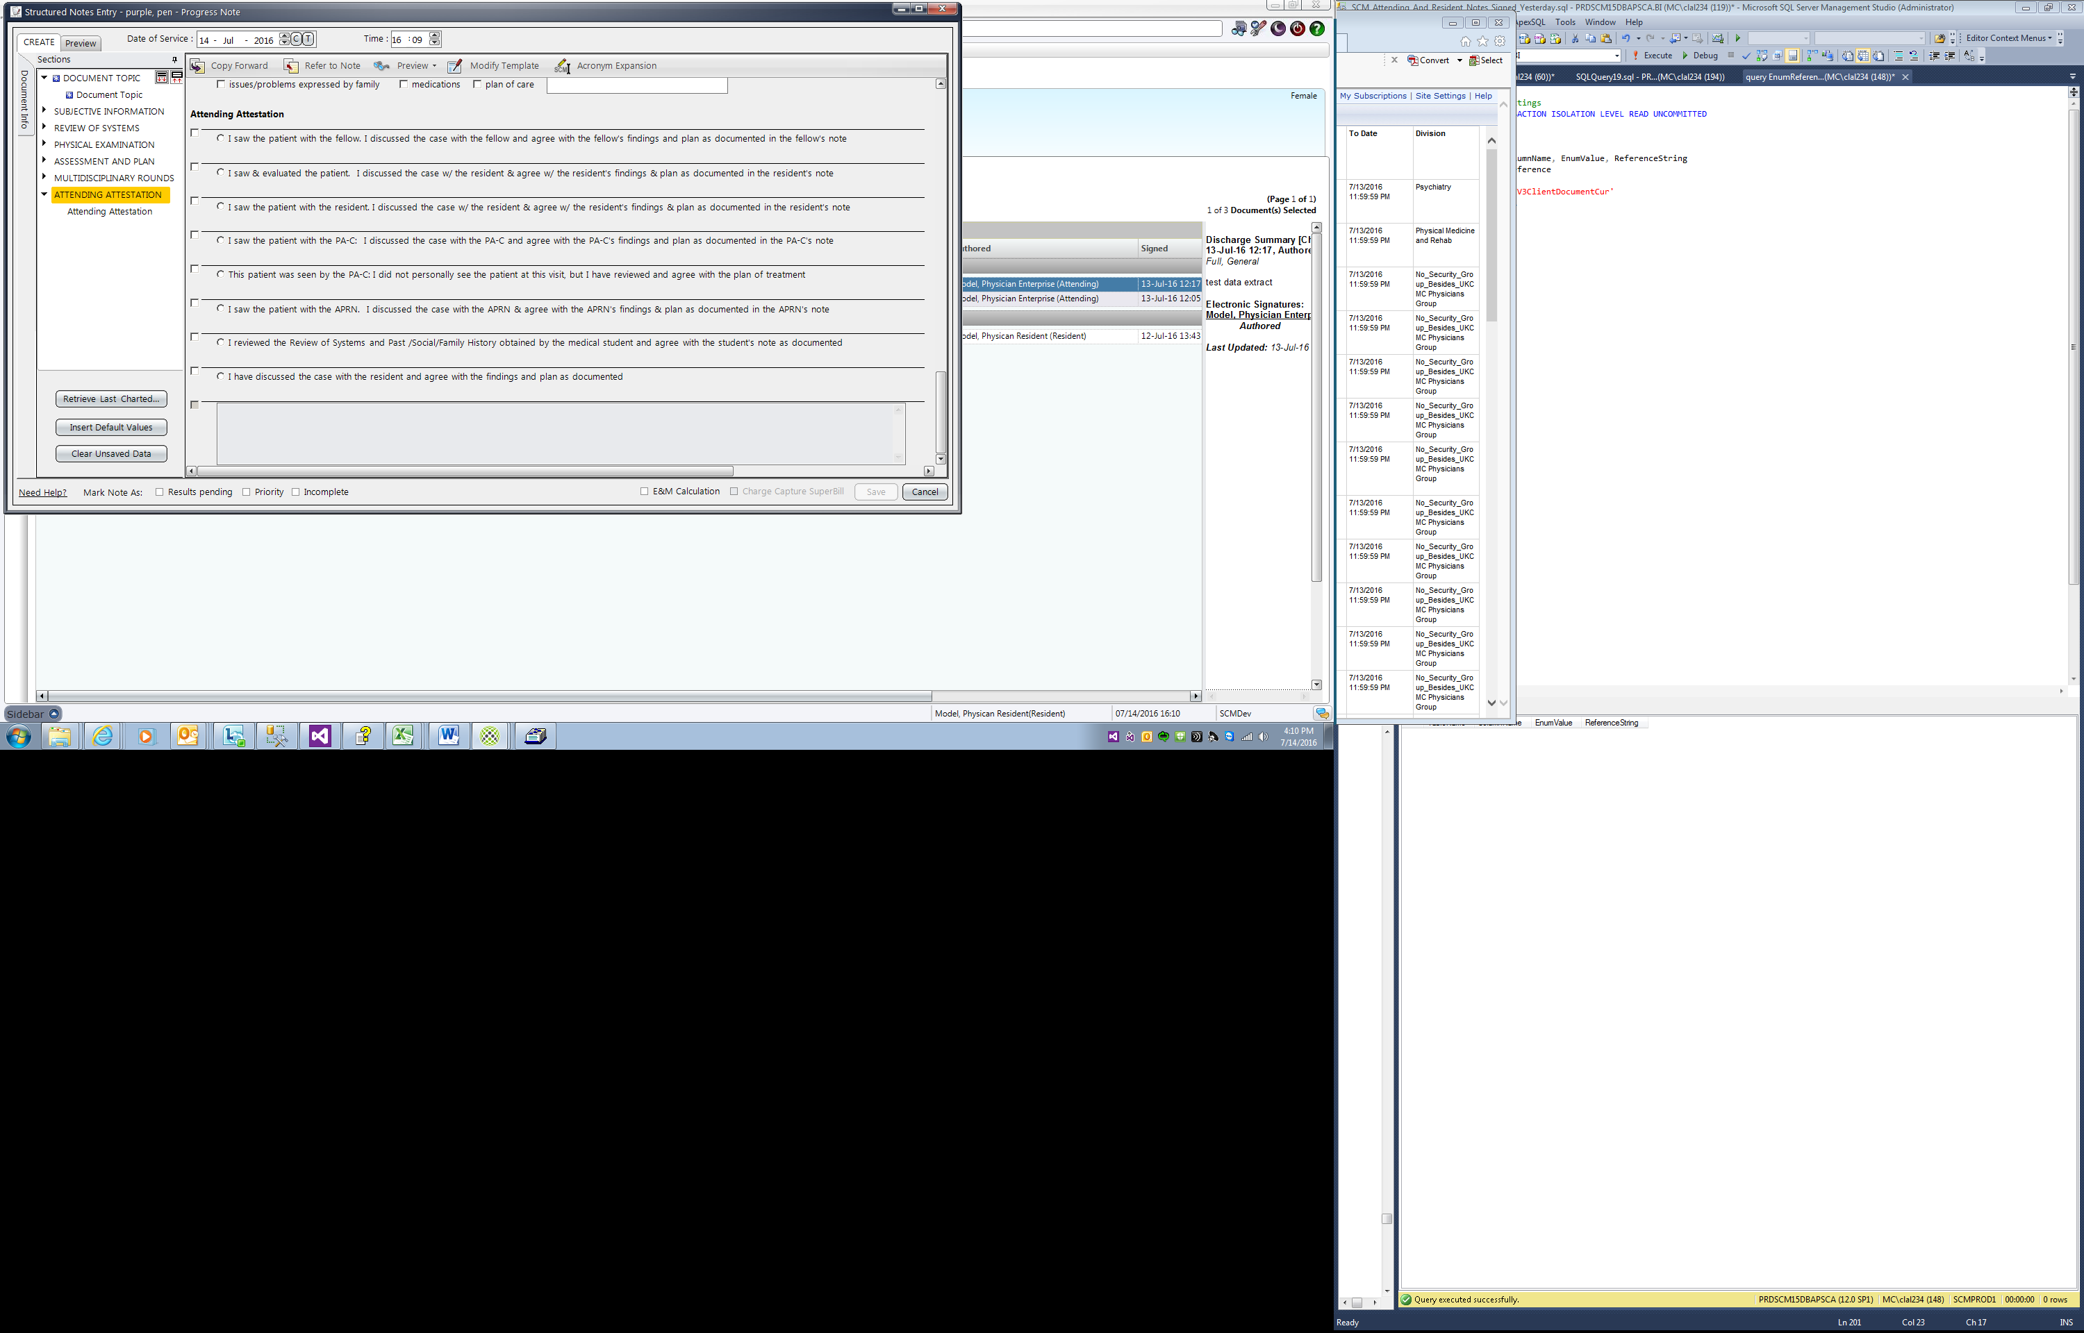

* Service: At the top of the document, the field labeled Service/ Team. This will be blank for documents which do have this field and for documents where this field was not populated by the provider. In the screen print below, it would be “ALL – Medicine / Allergy.”

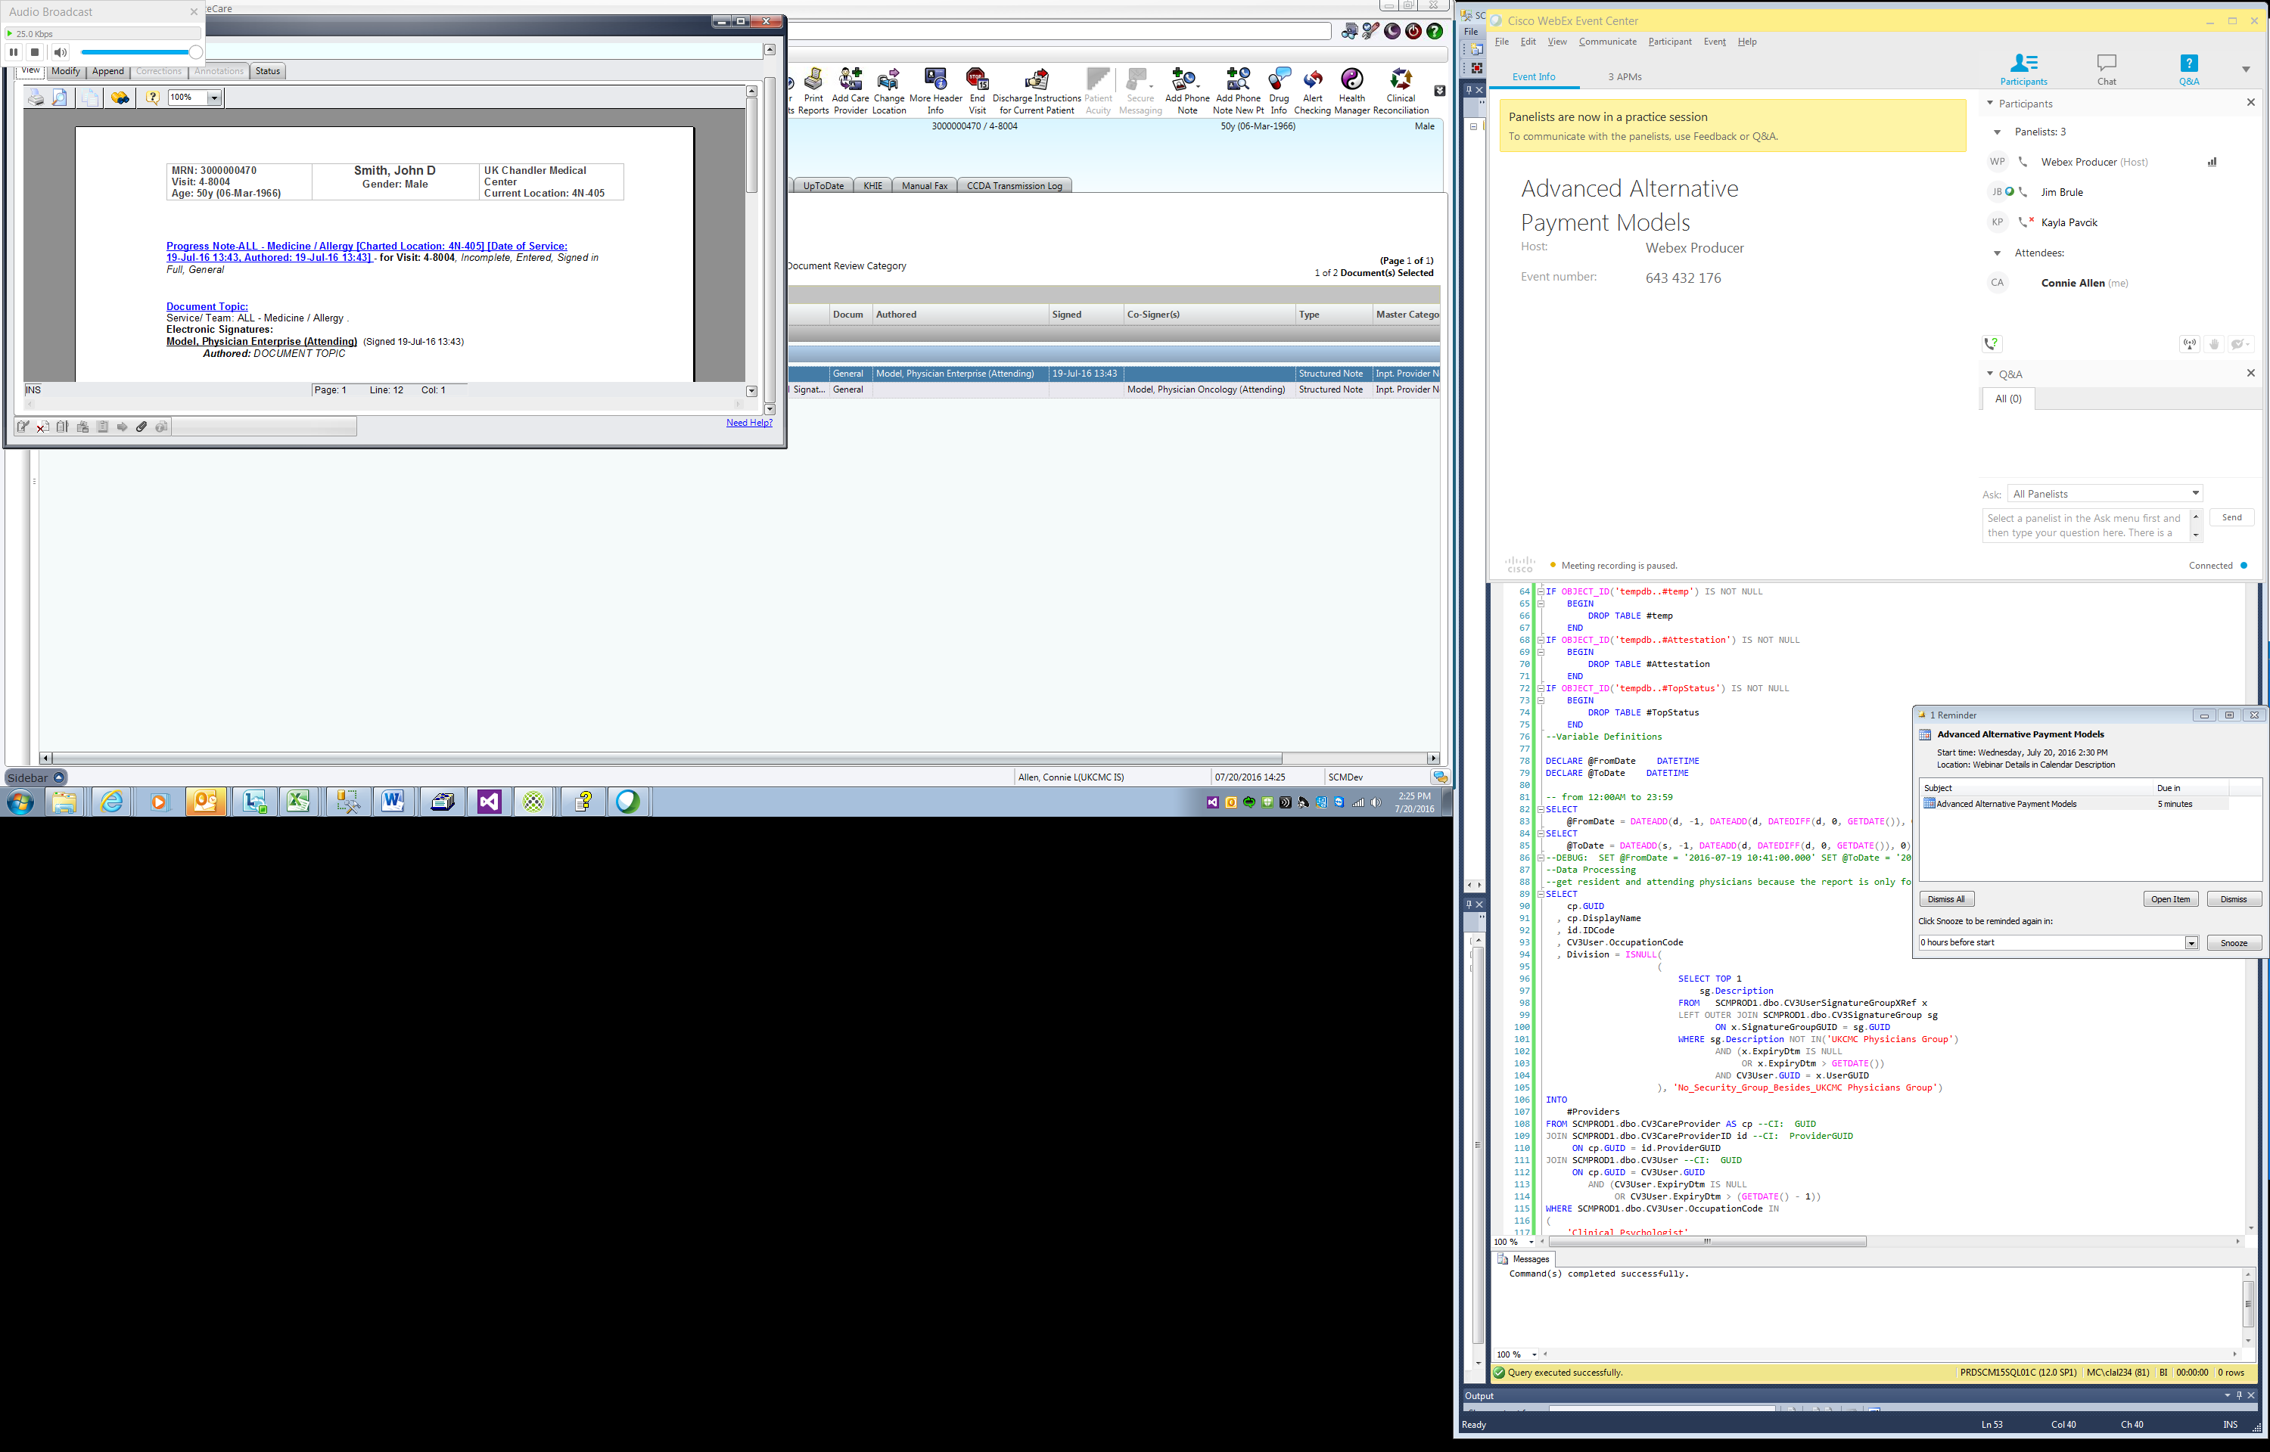

* From Date: Beginning date and time of the data extract
* To Date: Ending date and time of the data extract
* Division: First signature group besides UKCMC Physicians Group which is assigned the attending and is not expired, if no signature group exists for the attending, then the report includes the security group of the author, if not signature group exists for both the co-signing attending and the author, then “No_Security_Group_Besides_UKCMC Physicians Group”. If the attending does not have a signature group, then this will be the signature group of the author. This will be blank for documents where neither the attending nor the author have a signature group.

1. **SCM Mock-UP:**

*Please provide a visual example of how the report will be. A hand-drawn example is satisfactory.*

|  |
| --- |
| See above |

1. **Specification details beyond the visual examples:**

|  |
| --- |
| To be replaced with 3M’s computer assisted coding January 2017.  If the document is authored, signed and/or modified more than once yesterday, only information for the last authoring, signing or modification is included.  Each document only occurs on the daily data extract once. Include documents entered into SCM via interfaces from other applications, e.g. PICIS for Operative Reports.  If the visit has been discharged more than a year ago, any documents authored, signed or modified yesterday for that visit are excluded.  Billable providers have an occupation in SCM of 'Clinical Psychologist', 'Physician', 'Physician Assistant', 'Licensed Clinical Social Worker', 'Nurse Practitioner', 'Attending' or 'Resident’. |